**Activity 1**

**Question 1**

Before you can do this exercise, you'll need to download and **unzip qf-277zip**

Create a new Power BI Desktop file, and get a list of the top 1000 films of all time, as rated by **They Shoot Pictures, Don't They?**

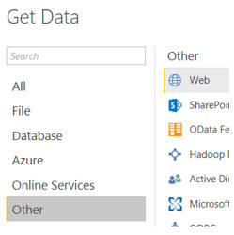

Create a table to look something like this:

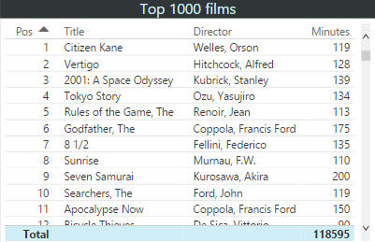

The films are in position order, and the table has a title and totals.

Save this Power BI file with the name **Citizen bloody Kane again**, then exit this instance of Power BI Desktop.

**Question 2**

|  |  |
| --- | --- |
| Exercise: | Load FTSE data, and create a report with a table, shape and image. |

Before you can do this exercise, you'll need to unzip [qf_279](https://www.wiseowl.co.uk/files/execise-question-files/qf-279.zip)

Create a new Power BI Desktop file, and get a list of the FTSE 100 shares

Add the image in the above folder, a shape, a table and a text box to get a report looking something like this:

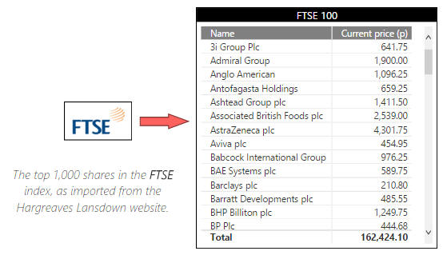

You can rotate the arrow by adding an arrow shape and changing its **Rotation** property.

Save this Power BI file as **Footsie**, then exit this instance of Power BI Desktop.

**Question 3**

|  |  |
| --- | --- |
| Exercise: | Create a matrix and return some appropriate images above. |

**Power BI | Basic reports exercise | Creating a Matrix within Power Bi Desktop**

Before you can do this exercise, you'll need to unzip [this file](https://www.wiseowl.co.uk/files/execise-question-files/qf-399.zip) **qf-399.zip**

**Count** of films by **Certificate** rating and **Genre:**

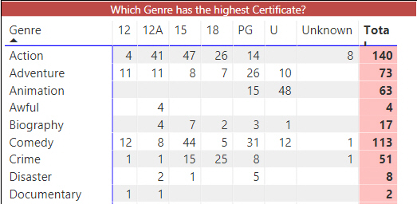

Your matrix will have all the certificates listed.

Notice how the certificates are in alphabetical order?

**CertificateID** is in a more sensible order; use this to reorder the **Certificate** column:

**Question 4**

Before you can do this exercise, you'll need to download and unzip [this file](https://www.wiseowl.co.uk/files/execise-question-files/qf-478.zip) **(qf-478.zip**

The above folder contains 3 files: two in CSV format and one in Excel.  Create a new Power BI report, and load these 3 files to create the following data model:

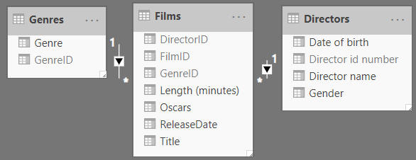

You'll have to create one of these relationships yourself. You should also hide the id fields, as no one will be interested in showing them in any report.

Rename the fields in the field well to make it more obvious what they represent:

|  |  |
| --- | --- |
| https://www.wiseowl.co.uk/files/exercise-images/e4467/i20.gif | https://www.wiseowl.co.uk/files/exercise-images/e4467/i21.gif |
| The original list ... | ... and the revised names |

Create a table listing out the directors:

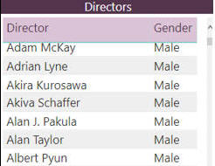

A table listing the directors - feel free to do your own thing with the formatting.

 Now create another table to list out the genres using the same look-and-feel:

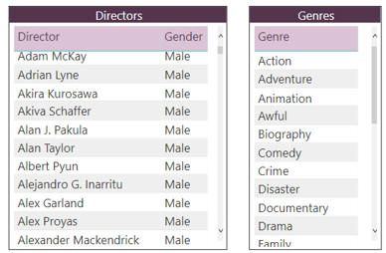

Remember that you can use the **Format Painter** tool to copy the formatting from one visual to another!

Create a third table to list out the films made by the director (or genre) that you've selected:

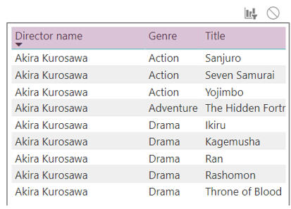

The list of films you should see when you click on **Akira Kurosawa**.

You'll need to click on the **Edit Interactions** button on the **Format** tab of the menu, and choose the **Filter** icon.

Save this report as **Go Akira**, then close it down.

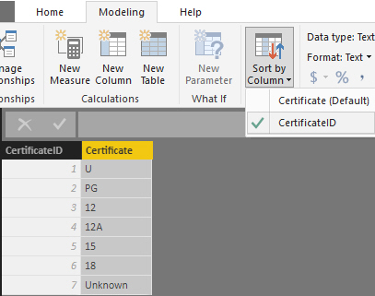

Sometimes the only way to get the order you want is to create a calculated column or separate table with a numbering system!

You now have a more familiar order:

Matrix Order Sort by column

Apparently the **Action** genre is too scary for young kids?

Lastly, to make the report a little more interesting add the images

Feel free to use a more interesting background colour.

Optionally save this report as **Still a better matrix than reloaded.pbix** and close it down.

**Question 5**

Before you can do this exercise, you'll need to download and unzip [this file](https://www.wiseowl.co.uk/files/execise-question-files/qf-477.zip) **qf-477.zip**

Create a new Power BI report, and load into it data from both worksheets in the workbook in the folder above:

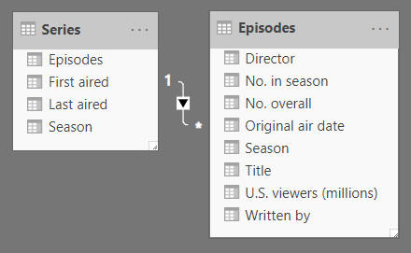

You should see this in **Model View**.

Hide and rename columns to get a simpler data model:

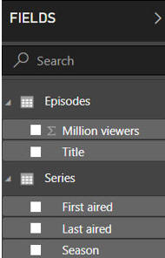

Hide some columns, and rename the **U.S. viewers (millions)** column to get a tidier data model, as shown here.

 Create a table to show average viewers by season:

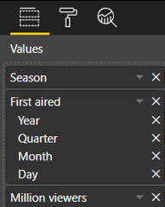

Initially your table should show these columns in the field well.

 Delete the extra date hierarchy fields added by Power BI to show the average viewers by season/year:

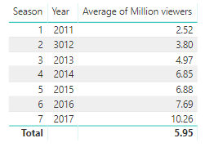

A table showing the average number of viewers of Games of Thrones episodes by season and year when first aired.

 Format your table so that it looks prettier (it absolutely doesn't have to look like the example below!):

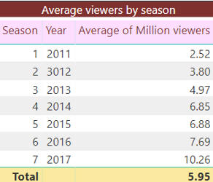

These are suggestions only! Someone has made changes to parts of the **Title**, **Total** and **Column headers** format sections for the table.

Save this report as **GOT it.pbix**, then close it down.

**Question 6**

|  |  |
| --- | --- |
| Exercise: | Compare Oscars won by genre and certificate for films using a matrix. |

Before you can do this exercise, you'll need to download and unzip [this file](https://www.wiseowl.co.uk/files/execise-question-files/qf-480.zip) **qf-480.zip**

Open the Power BI report in the folder above, and create the following report:

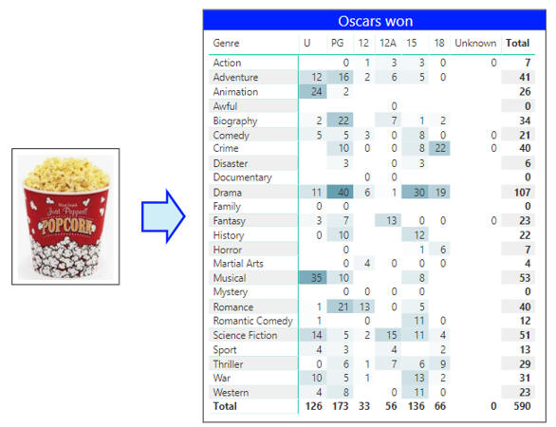

The picture you'll need is should be in the same folder. You'll also need to add an (arrow) shape and a matrix, and set conditional formatting for your matrix.  As for how to sort the certificates ... see below!

To get the certificates to appear in the correct order, you'll need to sort them by the **CertificateId** column and not the **Certificate** one.  To do this, select the **Certificate** column and choose this menu option:

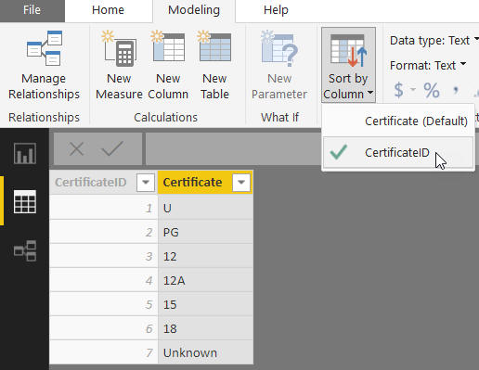

Choose to sort the **Certificate** column by the **CertificateId** one, using this dropdown on the **Modeling** menu.

When you've finished, save your report as **Films in Technicolor**, and close it down.

**Question 6**

|  |  |
| --- | --- |
| Exercise: | Use a matrix to compare the number of websites by country and type. |

**Power BI | Basic reports exercise | Create a matrix showing top websites by continent/type**

Before you can do this exercise, you'll need to download and unzip [this file](https://www.wiseowl.co.uk/files/execise-question-files/qf-479.zip) **(qf-479.zip**

Open the Power BI report file in the above folder:

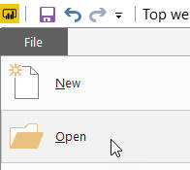

Choose to open an existing report.

This file contains a table listing out the top websites in the world as of March 2019:

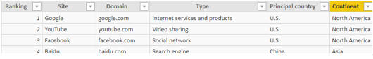

No huge surprises in the top 3 or 4!

Create a matrix analysing these as follows:

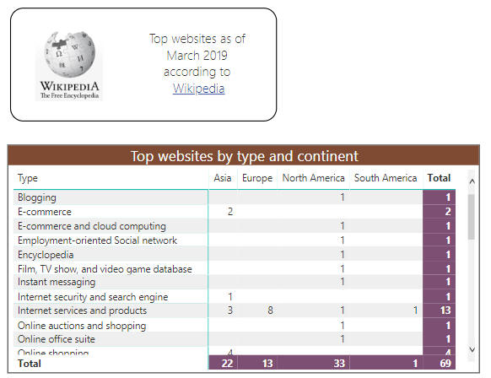

This matrix has a title and coloured totals.

On another page, create a matrix summarising the number of websites by continent and country:

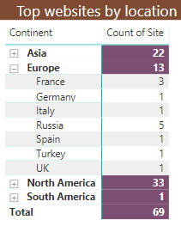

This is easier said than done! You'll need to click on the two icons shown in the hints below to achieve this.

These are the icons you'll need to use:

|  |  |
| --- | --- |
| Drill-down tool | + and - icons |
| This is above the matrix | This is in the **Row headers** category |

Save this report with the same name, then close it down.

**Question 7**

|  |  |
| --- | --- |
| Software: | [Power BI](https://www.wiseowl.co.uk/power-bi/exercises/power-bi-desktop/) |
| Topic: | [Basic reports](https://www.wiseowl.co.uk/power-bi/exercises/power-bi-desktop/basic-reports/) |
| Level: | Harder than average |
| Course: | [Introduction to Power BI](https://www.wiseowl.co.uk/courses/power-bi-desktop.htm) |
| Exercise: | Count the number of world events for each country and year. |

**Power BI | Basic reports exercise | Create a matrix summarising the number of events by country**

Before you can do this exercise, you'll need to unzip [this file](https://www.wiseowl.co.uk/files/execise-question-files/qf-400.zip) **qf-400.zip**

Create a new Power BI report.  Load the worksheets from the workbook in the above folder, and use them to create a data model:

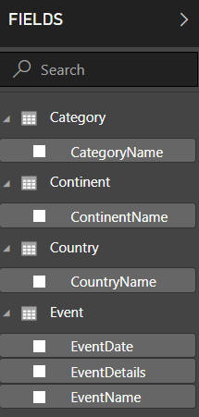

Your data model should only include columns you might want to display in reports.

Now create a table and matrix, such that when you click on a continent (such as **Africa** for this example) you see the number of events in each of its countries, by year:

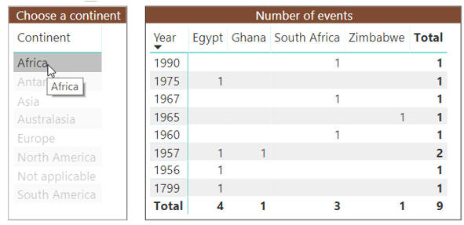

Your matrix should count the number of events for each year and country.

Save this report as **Out of Africa**, then close it down.